DM2008 Final Project
  - Tan Luke U2021081C

To be completely honest not much thought went into selecting this game to create. After reading the final project requirements, I started thinking of games I could create with just a single p5js sketch file
Something with scrolling screens or multiple pages seemed like it would be a bit more problematic to make, so I settled on the first idea that came to mind being an arcade style bullet hell shooter.
I’ve played this genre several years ago so I’m familiar enough with the game design and it seemed feasible enough to make.

The first thing made was the player entity, a spaceship with coordinates tied to mouseX and mouseY
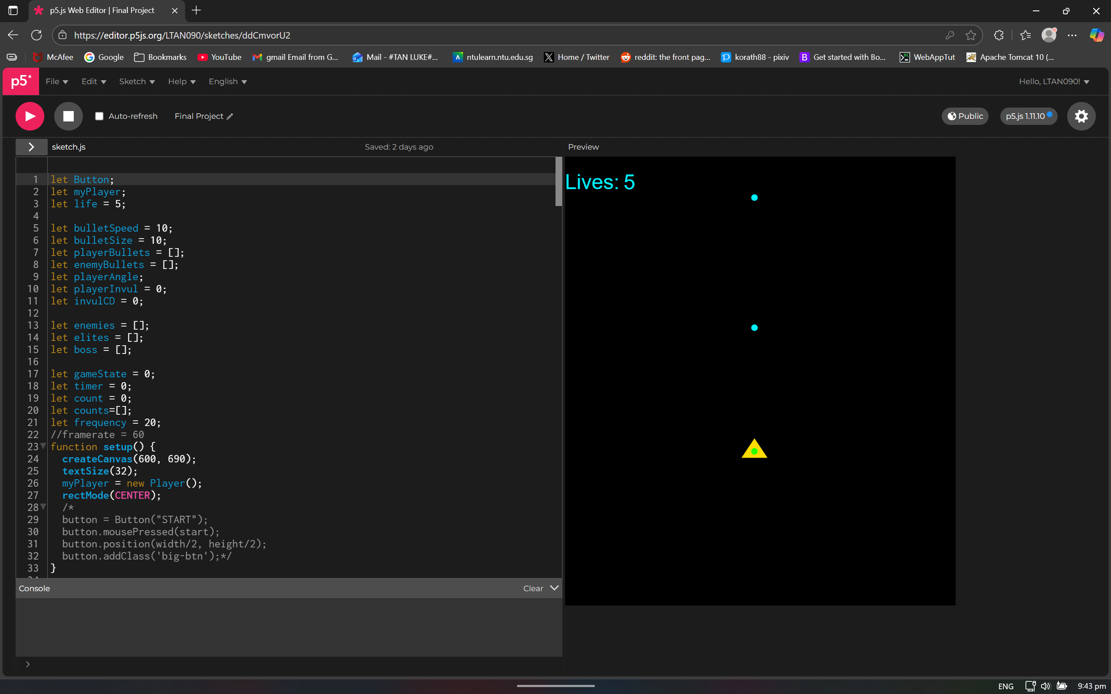
As standard for this type of game, the player hitbox is the green dot rather than the whole model making it possible to evade tighter bullet patterns
The player fires shots directly ahead at a set frequency
An enemy entity class was also created, a large circular hitbox, and using the collision detection code for 2 round objects.

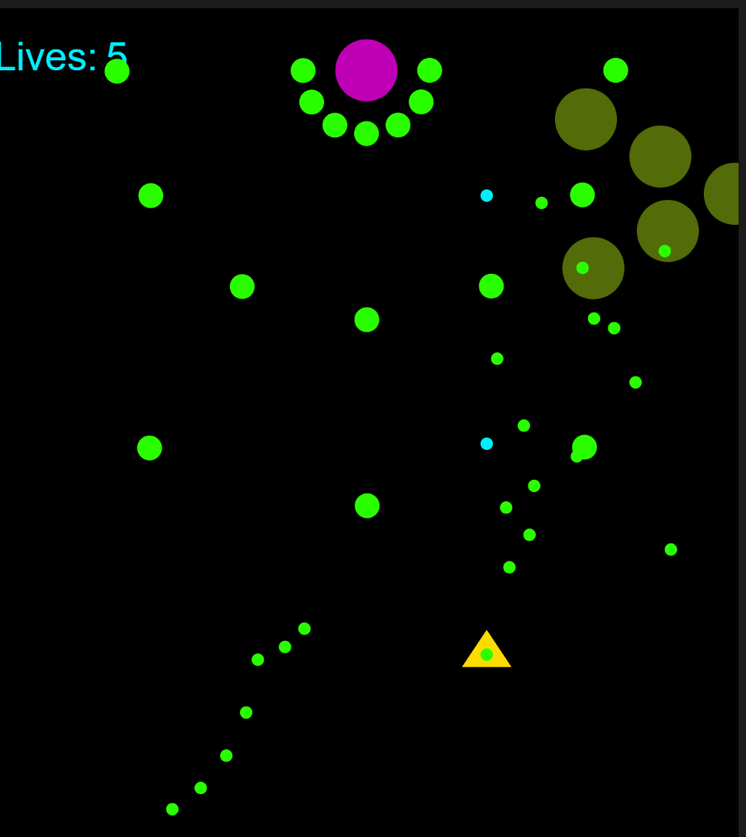
Afterwards, enemy movement and bullet patterns were added
There are 2 main types of bullet patterns, aimed shots and fixed spreads
The aimed shots are directed with the heading function while the spreads use a for loop
Enemy spawns were coded to fixed points in the stage timer

The player is given 5 lives and loses one when hit, or colliding with an enemy, after which will gain temporary invincibility to prevent chain life loss

Next, I implemented enemy drops, which had a chance to drop using the random function followed by an if condition, consisting of life refills, bullet power upgrades and spread shots. The pickup would spawn at the enemy death location and slowly fall downwards. For the demo, I set the bullet upgrade drops to be guaranteed for showcasing.
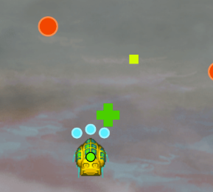

I also added a bomb function to clear the screen of enemy bullets and damage all enemies, with limited usages. Bomb drops were also added to the pickup pool.

I added assets for the background, sprites and music as well. All assets are taken from RPGmaker default assets, which I bought a few years ago.
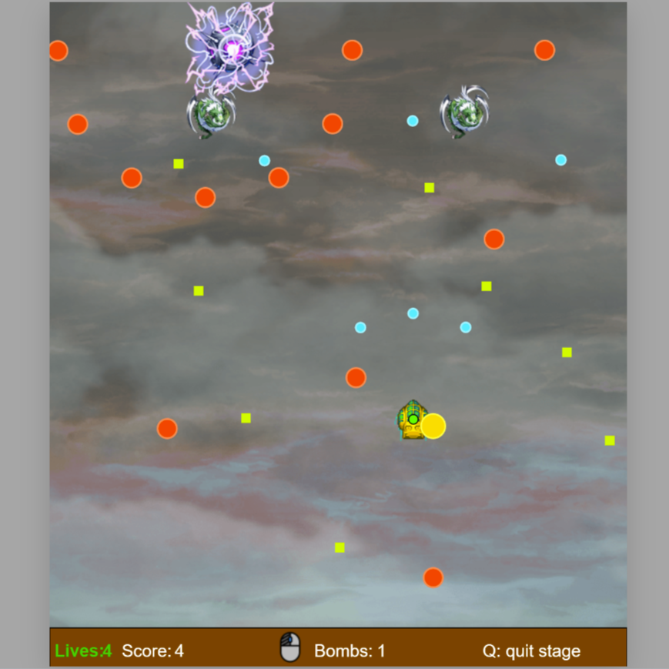

However one thing was still missing, a boss fight to end the stage
The boss would spawn when the player hit a score threshold after killing all other enemies, and had its own looping attack patterns cycling through different phases, which required me to add more bullet types.

Thus I ended up adding many more variables into the enemyBullet class such that each specific push could define the appearance, speed, size, number of bounces and direction of the projectile, including a new laser bullet type. Defeating the boss ends the stage in victory.